Eficacion: caballos de fuerza (hp) x Millas x galon (mpg)

¼ de milla

Cilindros

x = x_4_cyl, hp

y = y_4_cyl, mpg

c = color_4_cyl, ¼ milla

s = size_4_cyl*300, FORMA cilindros

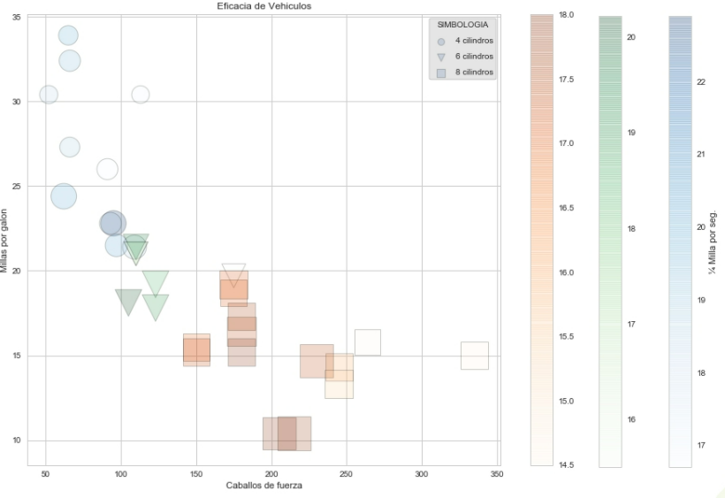

import pandas as pd

mtcars = pd.read_csv('./mtcars.csv')

mtcars.info()

import matplotlib.pyplot as plt

plt.style.use('seaborn-whitegrid')

%matplotlib inline

plt.figure(clear=True, figsize=(20, 10))

transparencia = 0.3

**#CARGUE 3 GRUPOS DE DATOS**

# 4 cilindros

x_4_cyl = mtcars[mtcars['cyl'] == 4]['hp']

y_4_cyl = mtcars[mtcars['cyl'] == 4]['mpg']

**color**_4_cyl = mtcars[mtcars['cyl'] == 4]['qsec'] #1/4 milla por el color

**size**_4_cyl = mtcars[mtcars['cyl'] == 4]['wt'] # tamaño

# 6 cilindros

x_6_cyl = mtcars[mtcars['cyl'] == 6]['hp']

y_6_cyl = mtcars[mtcars['cyl'] == 6]['mpg']

color_6_cyl = mtcars[mtcars['cyl'] == 6]['qsec']

size_6_cyl = mtcars[mtcars['cyl'] == 6]['wt']

# 8 cilindros

x_8_cyl = mtcars[mtcars['cyl'] == 8]['hp']

y_8_cyl = mtcars[mtcars['cyl'] == 8]['mpg']

color_8_cyl = mtcars[mtcars['cyl'] == 8]['qsec']

size_8_cyl = mtcars[mtcars['cyl'] == 8]['wt']

**#GRAFIQUE 3 GRUPOS DE DATOS**

# 4 cilindros

plt.scatter(x = x_4_cyl, y = y_4_cyl, c = color_4_cyl, s = size_4_cyl*300,

edgecolor = 'black', linewidth = 1, alpha = transparencia,

cmap = 'Blues', marker = 'o', label=**'4 cilindros'**)

**plt.colorbar().set_label('¼ Milla por seg.')**

**plt.legend()**

# 6 cilindros

plt.scatter(x = x_6_cyl, y = y_6_cyl, c = color_6_cyl, s = size_6_cyl*300,

edgecolor = 'black', linewidth = 1, alpha = transparencia,

cmap = 'Greens', marker = 'v', label='**6 cilindros'**)

**plt.colorbar()**

**plt.legend()**

# 8 cilindros

plt.scatter(x = x_8_cyl, y = y_8_cyl, c = color_8_cyl, s = size_8_cyl*300,

edgecolor = 'black', linewidth = 1, alpha = transparencia,

cmap = 'Oranges', marker = 's', label=**'8 cilindros'**)

**plt.legend**(labelspacing=1, markerscale=0.3, title='SIMBOLOGIA',

frameon=True, framealpha=0.5, facecolor='#CCCCCC', edgecolor='k')

**plt.colorbar()**

**plt.title('Eficacia de Vehiculos')**

plt.xlabel('Caballos de fuerza')

plt.ylabel('Millas por galon')

plt.savefig('mtcars.png')